|  |  |  |
| --- | --- | --- |
| **Lyng Primary School P.E Knowledge Organiser** | | |
| **Topic: Tennis** | Year 2 | Summer 1 |

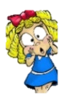



|  |  |
| --- | --- |
| **Key words** | |
| **Spelling** | **Definition** |
| TipToes | On the tips of your toes at all times ready to move to get in line with the ball. |
| Racket | Correct term of the equipment used to strike the ball. |
| Court | The area where tennis is played. |
| Movement | Moving the body regularly to get yourself around the court. |
| Stroke | Different types of strokes, where you are hitting the ball back at an opponent. |
| Singles | 1 player vs 1 player |
| Doubles | 2 players vs 2 players |

**Enquiry Questions**

* What are the three C’s?
* Can we react to the movement of a tennis ball?
* What does accuracy mean?
* Can we identify how to hold the racket when completing different types of shots?
* How do you perform a forehand shot?
* What is a rally?

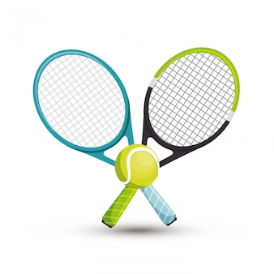

***“The only person you should try to be better than is the person you were yesterday” Novak Djokovic***

**– Mav Levy**

|  |  |  |
| --- | --- | --- |
| **Lyng Primary School P.E Knowledge Organiser** | | |
| **Topic: Tennis** | Year 2 | Summer 1 |



Learning Outcomes

* To develop control of an object or ball.
* To be able react quickly to the direction of movement of the ball.
* To be able to develop accuracy when hitting a target.
* To develop correct grip to hold the racket when completing different strokes.
* To be able to perform a forehand shot.
* To perform a rally along the floor to one another, for a challenge can they produce a rally in the correct manor of the floor with one/two bounces max.